Earnings announcements are full of surprises

(Trading on Earnings Announcements)

* Two main indicators:

1. SUE(standardized unexpected earnings)

The Standardized Unexpected Earnings, SUE, for a firm in a given quarter is constructed by dividing the earnings surprise by the standard deviation of earnings surprises:

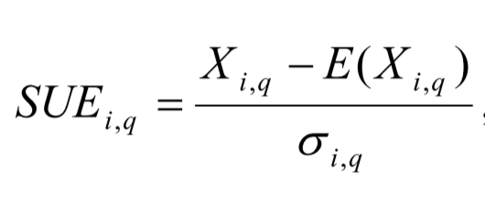

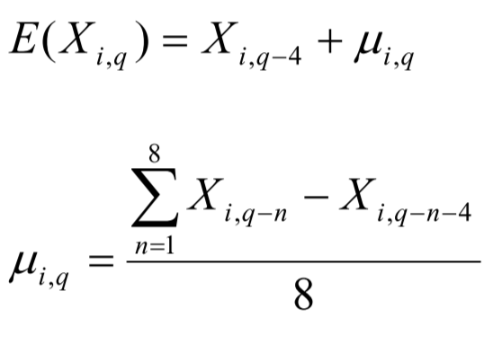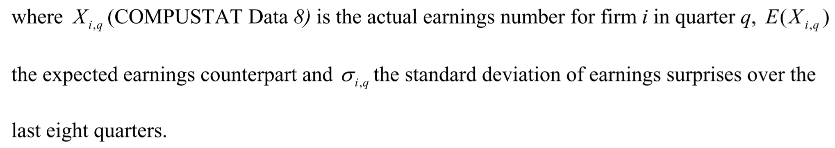

2. EAR(Earnings announcement return)

EAR is the abnormal return for firm i in quarter q recorded over a three-day window centered on the announcement date:

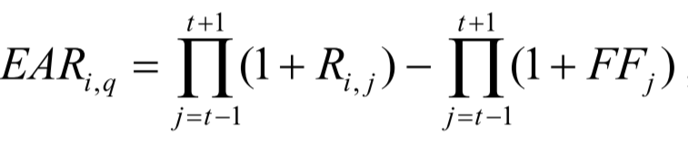

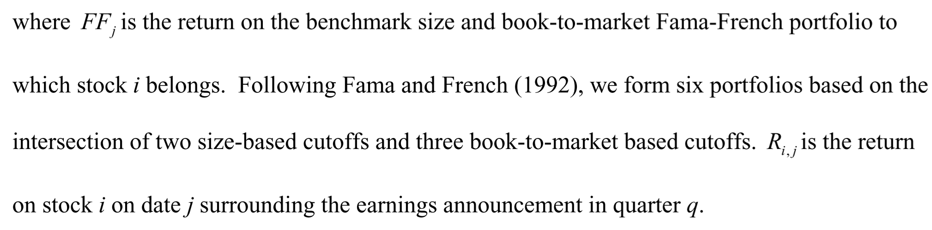

* One performance indicator:

ABR(abnormal return)

Returns start cumulating a day after the earnings announcement window ends and cumulate up to n days after the earnings announcement date.

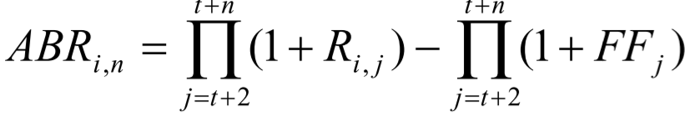

Data:

Earnings announcement return and three-day window period return

Range from 1987.1-2014.12

Trading Strategy:

Long the portfolio(stocks) with positive announcements

Short the portfolio with negative announcements

Procedures:

1.Rank the data according to SUE and EAR

2.Calculate ABR(abnormal return) in units of quarters

3.Build SUE and EAR two-dimensional table for analyzing

4.Compare SUE and EAR performance in the first quarter and the next three quarters

5.Combine SUE and EAR to estimate its performance

6.Compare EAR and Momentum effect

Important conclusions:

1. In short term (within first quarter), SUE has a stronger impact and creates a higher ABR especially on small-cap enterprises, EAR has a relatively lower impact but is very effective on large-cap enterprises

2. In long term (next three quarters), SUE’s impact is weakened and may create reversal impact whereas EAR’s impact is stable and more robust for large-cap enterprises

3. Cumulatively, EAR performs a higher return than SUE(persistent and compounding)

4. EAR and SUE are independent, and can be adopted simultaneously, which will yield a higher return performance than single strategy.

5. Momentum ≠ EAR, they two can also be used simultaneously, which will better for portfolio construction.

The key points of this passage---providing two indicators SUE and EAR as filters to build portfolio

For every quarter, we can form the portfolio as follows:

1. We calculate SUE and EAR for all the stocks in the COMPUSTAT Industrial Quarterly files as described in equations above.

To be more specific, we need four kinds of data:

a. actual earnings announcement number at the quarter q

b. expected earnings announcement number at the quarter q

c. earnings surprise data over the last 8 quarters (q-8, q-7, … q-1)

d. stock price daily return data on date t-1, t, t+1 (t is the announcement releasing date)

2. Rank the stocks as the ascending order of SUE and EAR separately to form two tables

3. Divide the tables into ten parts (quintile breakpoints)

4. pick the top 2 parts and bottom 2 parts from each table

5. pick the common stocks in top 2 parts of each table and same for bottom 2 parts

6. long the top stocks(positive) and short the bottom stocks(negative)

Now we have the portfolio filtered by two indicators.